Internship Reflection

Kazimir Nyzio

Internship advisor: Sukanta Basu
Program Director: Paul Roundy

University of Albany, Albany, New York

AATM 690

SUMMARY OF EXPERIENCE
The project that this internship belongs to is a collaborative effort between faculty and students at the University of Albany and the New York State Department of Financial Services. The intent of this collaboration is to provide a more meteorologically rigorous update to the NRI for NYS-based insurers and financial officers by targeting the local region with climatic analyses. This may involve all forms of severe weather from severe wind to lake-effect snowfall and tropical weather. My personal objectives were in improving my coding abilities through this experience as well as in contributing to and learning about the operations of collaborative research/consultations projects of this nature. My assignment was to investigate extratropical cyclones (ETCs), particularly of the nor’easter variety, using dynamically downscaled climate data.
PROJECT
- Background
The motivation of the background research was to investigate ETC, find other examples of tracking methodologies, and note the results of prior ETC climatologies for comparison and validation of the algorithm. I began with some compiled meta-analyses of ETC research (Schultz et. al 2019) followed by a couple dynamical studies (Uccellini et al. 1987, Zielinski et al. 2002) to refamiliarize myself with the phenomenon. Next, I looked for studies involving both reanalysis and projected tracking as well as dataset comparison (Bengtsson et al. 2006, Jung and Lackmann 2023, Spero et al. 2025, Galea et al. 2024, Hodges et al. 2017, Priestley et al. 2020). The primary studies used to reference storm track densities were Zhang and Colle 2018, Crawford et al. 2023, Priestley et al. 2022, and Hoskins and Hodges 2002. Initially, the tracking method outlined in Hodges 1994, Hodges 1995, and Hodges 1999 was to be the basis of the algorithm but were rejected due to outdated code and difficulty of adaption, in favor of Crawford et al. 2021.
- Methods
Once the base code was discovered, it was apparent that significant modifications would need to be performed to adapt it to this projects use case: the dataset it analyzed would need to be changed from WRF outputs to EDDEv2 outputs, the adjusted saving directory and graphing portions would need to be added, several tracking constraints implemented, and simultaneous tracking made possible. By the end of the process, very little of the original base code remained, primarily the pressure minimum detection portion.
Initially, according to prior literature, I intended to use vorticity minima for tracking but decided against it due to its complexity and the lack of adequate variables in EDDEv2 data to calculate it. Hourly data was also to be used, taking advantage of the new model’s temporal resolution, but through early testing, the computational time needed for analysis of the nearly 100-year dataset was deemed too large. Therefore, 6-hourly data was used instead (in line with most of the prior literature).
The conversion of file analysis was straightforward, with the change in map projection and coincident coordinate systems causing the most trouble. The running and saving process in the directory system of the remote lab computer was very foreign, having only coded locally jupyterlab. This involved batch processing (which proved critical in the running of the code), subdirectory organization, and saving of various output plots and csv files into their respective directories. Parallel processing was considered but did not prove necessary once the code was optimized. This optimization process consisted of narrowing the analysis area, confining tracks to a minimum of 4 points, confining the initial detection maximum to 1010 mb and the tracking (post-genesis) maximum to 1013 mb, the maximum turn angle between points to 60 degrees, minimum and maximum point-to-point distance thresholds to 12km and 700km respectively, neighborhood distance (search radius) to 200km, and pressure-minimum difference from the mean in the search radius to 1.5mb. Some of these parameters were set according to prior literature, and some were set according to intuition. With so many variables, substantial tuning with reanalysis data would be necessary to improve the algorithm. However, this is beyond the scope of this project.
The simultaneous tracking functionality was added late in process and its integration required rewriting of most of the tracking block. It was the most significant hurdle in the algorithm and caused several days of delay in testing and debugging. Had I considered the tracking capabilities more wholistically before starting rather than stepwise, I am sure many headaches could have been avoided. This approach will be kept in mind with future coding endeavors.
Once csv files (track point x/y, pressure, and tack ID) were acquired for each year, along with corresponding yearly track density plots and track pressure plots (each point colored by pressure), they were concatenated into single csv files for both emission scenarios for analysis. Additionally, filtered csvs were also created for stronger storms, defined as tracks containing a minimum below 980mb. Representing so much data in density, genesis, and lysis plots proved more difficult than expected. A log-scale was used, contour bounds adjusted by percentile, grid resolution defined (for the 2-dimensional histogram used), and smoothing parameter specified for each graphic type, emission scenario, and storm strength. However, the optimization of these graphic parameters for information presentation and interpretability was not straightforward. It’s apparent that conveying data can be just as challenging as creating or finding it.
3. Results
The process of tuning the tracking algorithm as coordinate types are correctly translated, tracking window narrowed/expanded, optimization procedures undertaken, multitracking incorporated, and time frame increased from a month to a year to the full EDDEv2 period is shown in Figure 1. This is only to depict the stepwise method used so individual subplot labels were not deemed necessary. The subsequent density plots (figures 2-6) demonstrate sensible behavior for ETCs, maximizing overall densities in the Canadian Maritimes and suggesting western weighted genesis densities and eastern weighted lysis densities. One notable finding is a very minor increase in the number of total tracks in the higher emission scenario (by 2.9%) but a decrease in the stronger, <980 hPa, storms (by 8.1%). In both scenarios, <980 hPa storms made up 8 to 9% of the total tracked systems.
The most spurious findings derive from the track density maps, which highlight maxima in several areas across all types of plot and data. Some approximate locations of these peaks include Quebec City, CA, the southern Vermont/New York border, Miscou Island, CA, and Staunton, Virginia. These ‘hotspots’ seem unrealistic, though upon investigating the individual tracks that pass through these areas, it was found that they do not overlap, but rather cluster over these spots, making a grid definition/snapping issue an unlikely culprit. Another inaccuracy is a probable underrepresentation of tracks over the Atlantic. Upon testing with a larger domain size and seeing no difference, it was noted that the eastern bounds of the EDDEv2 data had been reached. It is suspected that shorter tracks which extend beyond this boundary are being removed by the track length constraint, reducing track numbers in these areas. A global dataset may therefore be necessary for accurate tracking of ETCs anywhere in the vicinity of the current EDDEv2 domain edges.

Acknowledgments.

WHAT WAS ACCOMPLISHED
The “skeleton” for an ETC tracking code inputting EDDEv2 netcdf files and outputting csvs/plots was created and made available via Github then analyzed to determine the plausibility of the results. Future work using this basis may take interest in tuning the parameters of the algorithm to improve performance as well as investigating the spurious hotspots that prevailed in the tracks. This process informed me about the complexity of such algorithms, difficulty of adjusting in such an interconnected system, and a sense of the time investment required. It also improved my coding abilities and capability navigating a terminal system, even if ai was used to assist where necessary. I met my goals for the most part, though the time constraint makes it unlikely that the algorithm is usable for academic or profession purposes in its present state. Thus, it currently contributes little to the larger associated project.

Acknowledgements
This project was funded by the New York State Department of Financial Services and was granted by UAlbany’s Center for Excellence for academic credit in the department’s Applied Meteorology program.
I would also like to thank my advisor Sukanta Basu and fellow project contributors Chris Yu and Ekaterina Belash for their guidance in project orientation, coding, and paper writing process, respectively.

Data Availability Statement.
All EDDEv2 data analyzed was accessed via Amazon Web Services and analyzed using The UAlbany Research IT system.

REFERENCES
Schultz, D. M., and Coauthors, 2019: Extratropical Cyclones: A Century of Research on Meteorology’s Centerpiece. Meteor. Monogr., 59, 16.1–16.56, https://doi.org/10.1175/AMSMONOGRAPHS-D-18-0015.1Batchelor, G. K., 1981: An Introduction to Fluid Dynamics. Cambridge University Press, 615 pp.
Uccellini, L. W., and P. J. Kocin, 1987: The Interaction of Jet Streak Circulations during Heavy Snow Events along the East Coast of the United States. Wea. Forecasting, 2, 289–308, https://doi.org/10.1175/1520-0434(1987)002<0289:TIOJSC>2.0.CO;2.
Zielinski, G. A., 2002: A Classification Scheme for Winter Storms in the Eastern and Central United States with an Emphasis on Nor'easters. Bull. Amer. Meteor. Soc., 83, 37–52, https://doi.org/10.1175/1520-0477(2002)083<0037:ACSFWS>2.3.CO;2.
Bengtsson, L., K. I. Hodges, and E. Roeckner, 2006: Storm Tracks and Climate Change. J. Climate, 19, 3518–3543, https://doi.org/10.1175/JCLI3815.1.
Jung, C., & Lackmann, G. M. (2023). Changes in tropical cyclones undergoing extratropical transition in a warming climate: Quasi-idealized numerical experiments of North Atlantic landfalling events. Geophysical Research Letters, 50, e2022GL101963. https://doi.org/10.1029/2022GL101963
Spero, T. L., and Coauthors, 2025: EPA Dynamically Downscaled Ensemble (EDDE): Datasets for Adaptation and Resilience Planning for Environmental Endpoints. Bull. Amer. Meteor. Soc., 106, E1539–E1557, https://doi.org/10.1175/BAMS-D-24-0251.1.
Galea, D., K. Hodges, and B. N. Lawrence, 2024: Investigating Differences between Tropical Cyclone Detection Systems. Artif. Intell. Earth Syst., 3, e220046, https://doi.org/10.1175/AIES-D-22-0046.1.
Hodges, K., A. Cobb, and P. L. Vidale, 2017: How Well Are Tropical Cyclones Represented in Reanalysis Datasets?. J. Climate, 30, 5243–5264, https://doi.org/10.1175/JCLI-D-16-0557.1.
Priestley, M. D. K., D. Ackerley, J. L. Catto, K. I. Hodges, R. E. McDonald, and R. W. Lee, 2020: An Overview of the Extratropical Storm Tracks in CMIP6 Historical Simulations. J. Climate, 33, 6315–6343, https://doi.org/10.1175/JCLI-D-19-0928.1.
Zhang, Z., and B. A. Colle, 2018: Impact of Dynamically Downscaling Two CMIP5 Models on the Historical and Future Changes in Winter Extratropical Cyclones along the East Coast of North America. J. Climate, 31, 8499–8525, https://doi.org/10.1175/JCLI-D-18-0178.1.
Crawford, A. D., M. R. McCrystall, J. V. Lukovich, and J. C. Stroeve, 2023: The Response of Extratropical Cyclone Propagation in the Northern Hemisphere to Global Warming. J. Climate, 36, 7123–7142, https://doi.org/10.1175/JCLI-D-23-0082.1.
Priestley, M. D. K. and Catto, J. L.: Future changes in the extratropical storm tracks and cyclone intensity, wind speed, and structure, Weather Clim. Dynam., 3, 337–360, https://doi.org/10.5194/wcd-3-337-2022, 2022.
Hoskins, B. J., and K. I. Hodges, 2002: New Perspectives on the Northern Hemisphere Winter Storm Tracks. J. Atmos. Sci., 59, 1041–1061, https://doi.org/10.1175/1520-0469(2002)059<1041:NPOTNH>2.0.CO;2.
Hodges, K. I., 1994: A General Method for Tracking Analysis and Its Application to Meteorological Data. Mon. Wea. Rev., 122, 2573–2586, https://doi.org/10.1175/1520-0493(1994)122<2573:AGMFTA>2.0.CO;2.
Hodges, K. I., 1995: Feature Tracking on the Unit Sphere. Mon. Wea. Rev., 123, 3458–3465, https://doi.org/10.1175/1520-0493(1995)123<3458:FTOTUS>2.0.CO;2.
Hodges, K. I., 1999: Adaptive Constraints for Feature Tracking. Mon. Wea. Rev., 127, 1362–1373, https://doi.org/10.1175/1520-0493(1999)127<1362:ACFFT>2.0.CO;2.
Crawford, A. D., E. A. P. Schreiber, N. Sommer, M. C. Serreze, J. C. Stroeve, and D. G. Barber, 2021: Sensitivity of Northern Hemisphere Cyclone Detection and Tracking Results to Fine Spatial and Temporal Resolution Using ERA5. Mon. Wea. Rev., 149, 2581–2598, https://doi.org/10.1175/MWR-D-20-0417.1.

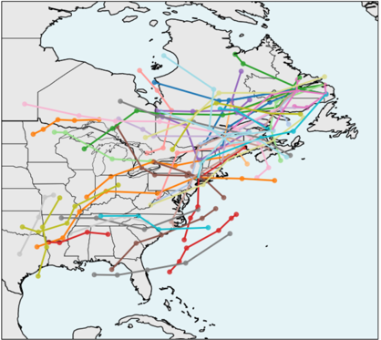
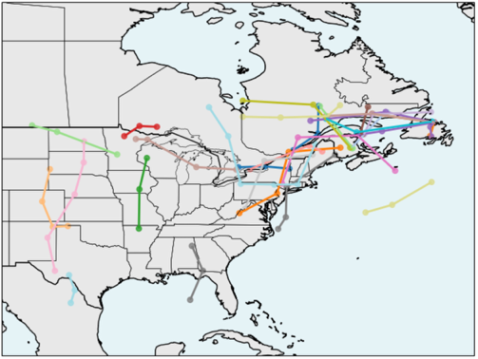
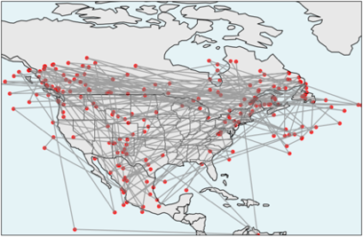
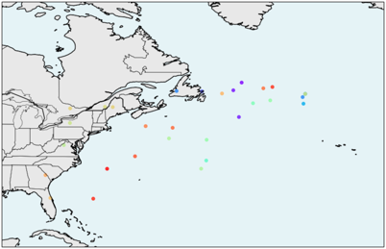
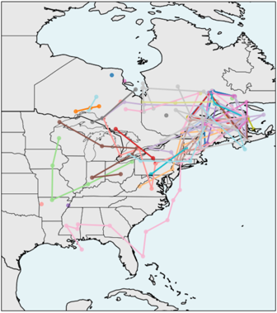
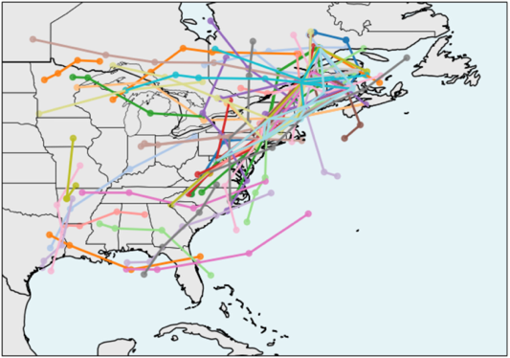
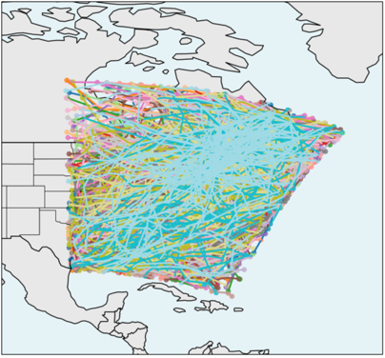
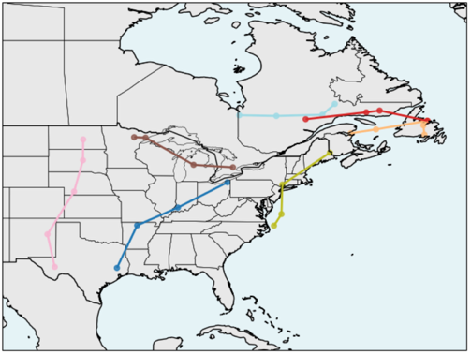
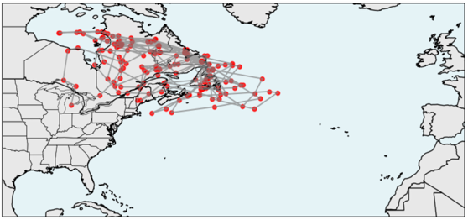
FIGURES

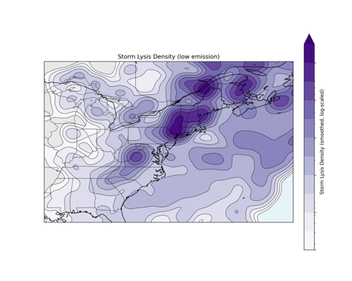
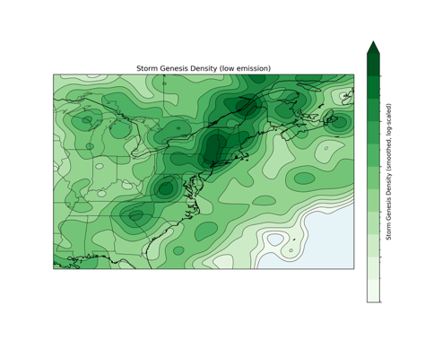
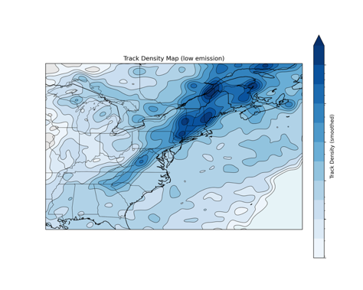
Fig 1: A collection of test results from the development of the tracking algorithm

Fig 2: Total, Genesis, and Lysis density for SSP2-4
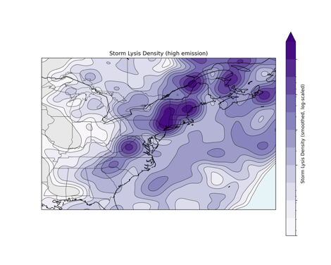
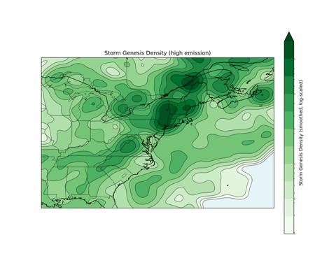
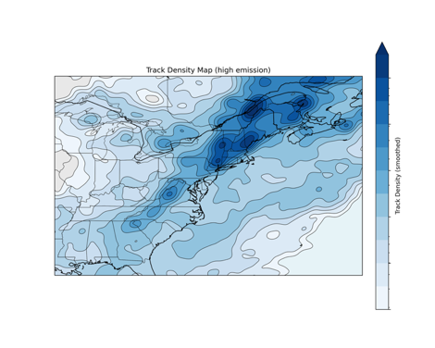

Fig 3: Total, Genesis, and Lysis density for SSP3-7.0
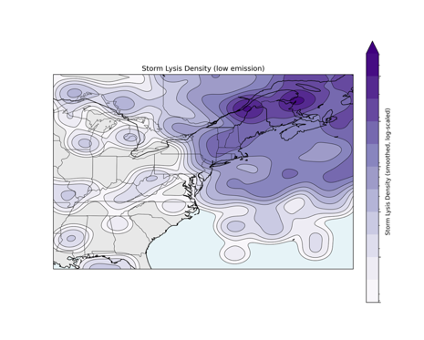
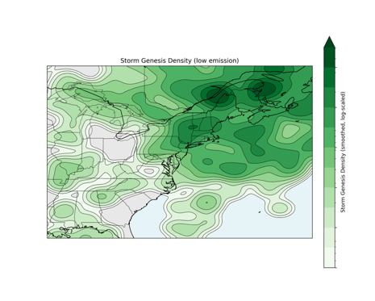
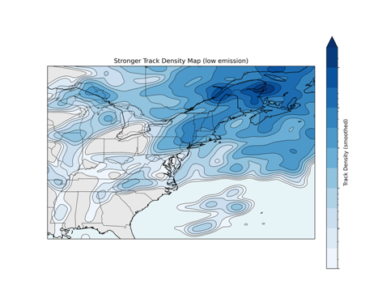

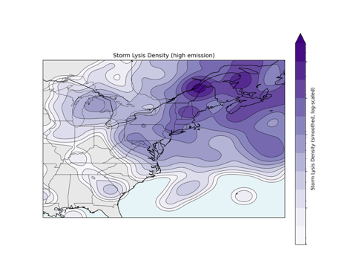
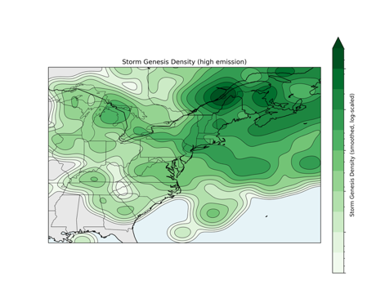
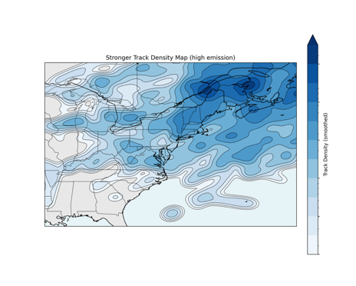
Fig 4: <980 hPa Total, Genesis, and Lysis density for SSP2-4.5

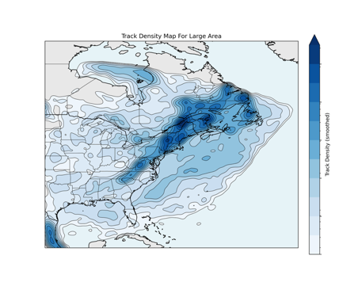
Fig 5: <980 hPa Total, Genesis, and Lysis density for SSP3-7.0

Fig 6: Large-Area Track Density SSP2-4.5

